CSE420
Samuel Marrujo
Professor Yu
Lab 09

Mesh
In this part of the lab, it was a modification of the original canvas program. After some modifications to the program, and adding in the functions asked for, the result was the following reproduction of the figure. Because of this change to the functions and the addition of the figure, I believe I was able to accomplish this task successfully, since there were no errors and the display window was changed. Here are my results for this program:

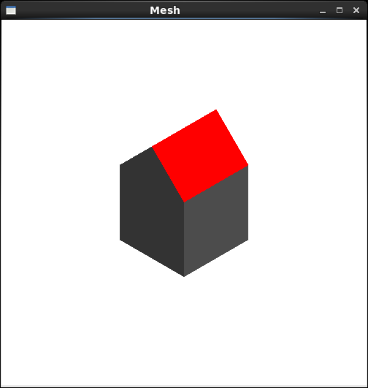

Tween

In this part of the lab, we were to reproduce the animation of the tween. I was able to successfully complete this as shown below, since the object has moved entirely, with a change in its legs and arms:

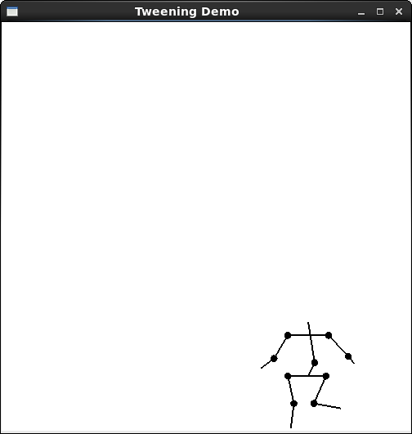
EC: Morph

Here is the change from a T to an I animated, and the other way around:

